'Youth in Action' Programme  Action 4.6 | 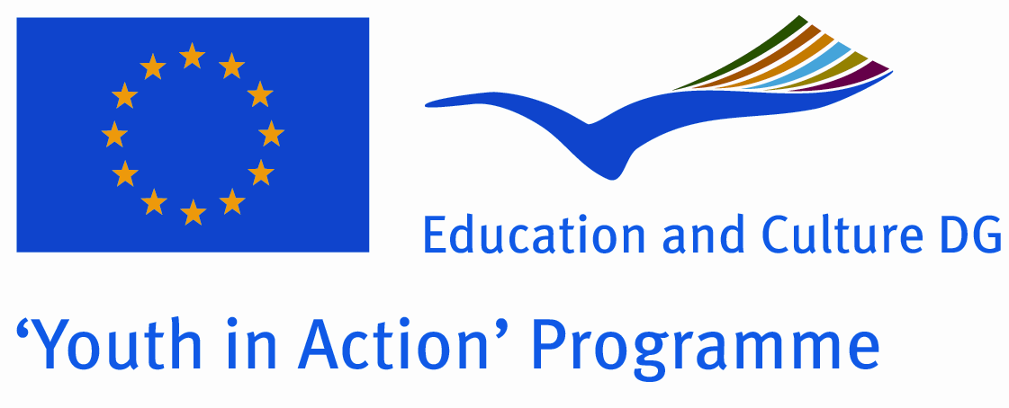

Project name:
YOUTH CITIZENSHIP AND SOCIAL CHANGE

ACTIVITY 1:

Training course 1 - Youth sitizenship and social change
18-24.03.2011, Sofia, Bulgaria- 30 participants

The aim of this training course is to support the professional development of youth workers and youth leaders by extending their competencies to integrate European citizenship within their projects and practice. The Training Course is supported by EU Youth in Action programme (Action 4.6).

Objectives: The following objectives have been set in order to reach the aims as described above:
- To extend the participants’ knowledge and understanding of Europe, citizenship and young people in Europe;
- To enable participants to reflect upon and to address key values related to European citizenship, such as human rights, democracy, participation and intercultural respect;
- To critically and creatively reflect about the role and relevance of Europe and European citizenship for young people and for youth work today and in the future;
- To further develop the participants’ skills and abilities to reflect about intercultural learning, multicultural society and their translation into and implications for youth work practice;
- To increase the participants’ professional competence in developing and evaluating projects with young people which aim at empowering them or raising their own understanding and practice of European citizenship;
- To acquire competence in dealing with European youth programmes, the policies behind them and the decision-making structures associated to them;
- To equip the participants with the knowledge and competence necessary to make use of existing funding mechanisms and programmes for young people;
- To gather evaluation elements for the further integration of European citizenship into youth work practice.

Methodology: Methodological guidelines the course will be based on the principles and practise of non-formal education in youth worker and youth leader training.

In conjunction with the topic of the course – European citizenship – this determines that the learning process will:
- be based on the intrinsic motivation of the learner;
- generally not imply the control of individual learning achievement; - be learner-centred and based on the experiences of participants;
- be based on a personal responsibility for learning, supported by a strong group dimension and a collective approach;
- enable participants to apply and transfer what they learned to their youth work practise;
- take into account the needs and motivations of participants and be open to regular feed-back and evaluations;
- be thoroughly evaluated and documented to gain a maximum multiplying effect;

Results: As a result of their attendance of the course, participants will have developed:
- a critical understanding of the tensions, opportunities and challenges arising from an enlarging Europe; - the capacity to debate ideas of ‘European citizenship’;
- the potential to integrate European dimensions into their work with young people, particularly ‘cascading’ these capabilities to young people.
- reflections on experiences and stimuli on how to deal with the topic of European citizenship, both in non-formal and formal learning environments;
- the skills and abilities necessary in order to set up a project on European citizenship with young people and the tools to benefit from the gained experience (increased visibility and evaluation possibilities);
- their understanding of intercultural learning and its relation to European citizenship;
- their motivation and capacity to enrich and contribute to conceptual developments and debates on European Youth Policy and on European level youth worker and youth leader training;
- -a broader and clearer understanding of European citizenship deriving from the institutional co-operation in this particular area;
- -a clearer and extended knowledge of European youth programmes and the possibilities these programmes offer to support local projects for European citizenship;
- a network of contacts and potential partners in Europe.

Participants: Number of participants: 30

Profile of participants in the training course YOUTH CITIZENSHIP AND SOCIAL CHANGE.
In General all the participants in the training courses should be:
- youth workers/leaders directly working with groups of young people in their own communities,
- having/willing to have educational aims in their activities to develop skills of young people for active citizenship,
- motivated to improve their skills in citizenship education through experiential learning,
- ready to learn from their own experience and be fully involved in training activities during the entire course,

Participants selection criteria: All candidates must apply by using the enclosed application form. Applications should be sent to the PTPI. The training team will try as far as possible to ensure a balance between geo-graphical origin, different types of experience, cultural backgrounds and organisations, gender, institutions or projects as well as different concepts of citizenship and consequently try to compose a group of participants that represents the diversity and richness of a multicultural Europe. Participants having the possibility within their organization (green light from their hierarchy/colleagues!) to set up projects and cooperation activities within the Youth In Action programme after the training course.

Eligible countries:
Greece, Hungary, Portugal, Germany, Czech Republic, Slovakia, Bulgaria and Romania

Financial conditions:
PTPI Plovdiv will provide board, lodging and programme costs during entire training course. 50% of travel costs will be covered by organisers of the course.
We ask for your contribution to this training course, which is: 50% of your travel costs;

If you are interested in what was presented above, please fill-in application form (which is below) and send it to us by e – mail: ptpiplovdivbg@gmail.com till 10th of January, 2011.

If you have any question, please don’t hesitate to contact Zina Lyubenova by phone:
00359 887 584 054

Greetings,

Zina Lyubenova

APPLICATION FORM
Personal Data
The contact details you provide us below will be used for all correspondence!
First Name  [as on your passport] |  | Family Name  [as on your passport]
Nationality |  | Age: |  | Gender | Female  Male
Complete address
Postal code |  | Town |  | Country
Phone (preferably mobile)  [with full international dial codes] |  | Fax  [with full international dial codes]
Email |  | Website

Language(s) abilities: Please mention all languages in which you are able to work and indicate your level for each of it (B-basic, G-good, VG-very good, F-fluent, MT-mother tongue) Anyway we would like to remind you that main working language will be English.
 | Listening | Speaking | Reading | Writing
English
Other languages
[please specify]

Do you have any special needs or requirements that the host organisation should know about? (E.g. mobility, medical needs, allergies, dietary restrictions, smoker/non-smoker)

If you are accepted as a participant on this course, you are requested, if needed, to apply by your own for a visa. The organisers will support you by providing an invitation letter. Therefore provide us:
Passport number |  | Place of issue
Date of issue |  | Date of expiry

The invitation letter will be sent to the above mentioned address which we use for all correspondence.

Your organisation
Name
Complete address
Postal code |  | Town |  | Country
Phone  [with full international dial codes] |  | Fax  [with full international dial codes]
Email |  | Website
Activity level | # local # regional # national # international

Please describe briefly your organisation
What are the objectives, main activities and target group of your organisation?

What are your roles (volunteer, youth worker, board member, director ...) and your tasks? Please say how long you have been involved in youth work?

Knowledge and experiences

What type of training (if any) have you followed regarding international youth work, non-formal education, cultural diversity, human rights education, YOUTH programme or Youth in Action programme?

Motivation and Expectations:
Please describe briefly your understanding cultural diversity?

What would you like to learn, understand and experience during this training course?

What contributions can you bring for the training course?

How do you plan to use the outcome of this activity in your work with young people afterwards?

Please indicate us the name and full contact details of a person to be contacted in case of emergency during the course
Name
Complete address
Postal code |  | Town |  | Country
Phone  [with full international dial codes] |  | Fax  [with full international dial codes]
Email

Applications should be sent by e-mail to: ptpiplovdivbg@gmail.com no later than January 10th, 2011.
If for any reason you are no longer able to attend the course, please inform us as soon as possible so that the training organisers can ensure a replacement from the waiting list.

